Nolan Patterson

CIT 212

April 26, 2023

Final Project Planning

Topic:

My topic for the final project is a review of the lessons learned this semester. This project will serve as a sort of master portfolio to showcase most of the larger projects that were completed during this class.

Wire Frame Diagrams:

Landing Page Diagram

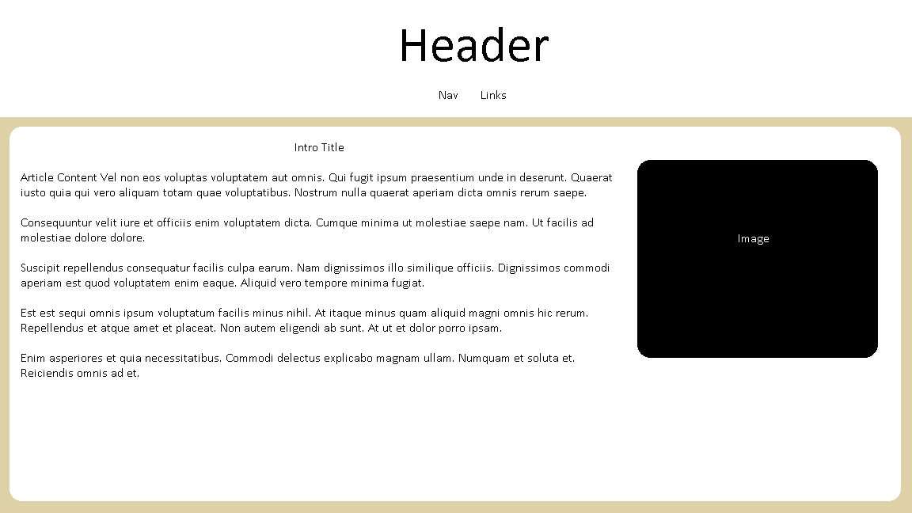

Flip Card Page Diagram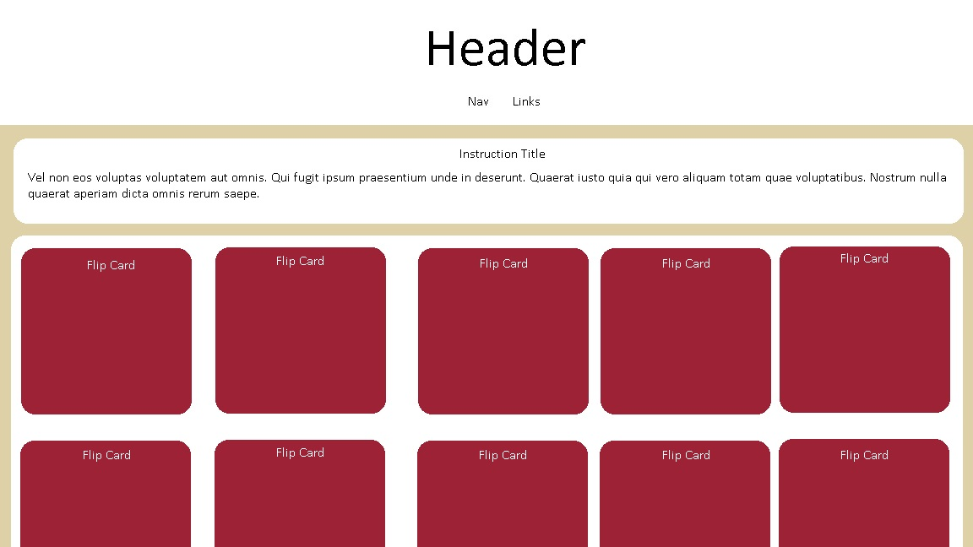

About Page Diagram